**Team Final Project**

Ruby Villalona

CSIT 114

Montclair State University

Professor Michelle Zhu

June 28, 2024

**The Library Management System**

The Library Management System is a Python application developed to manage a library's book collection viably through a command-line interface. This system uses classes, inheritance, modules, exception handling, and file operations, forming the pillar of programming as classes, modules, and exceptions are mechanisms for solving programming problems. In contrast, file operations give librarians and book enthusiasts a rich and interactive experience.

**Design Overview**

The Book and Library classes provide the identities of the objects and encompass principal characteristics of the system itself, the fundamental urge of books and libraries. The book class describes the individual books, including title, author, year, and ISBN fields. This class aims to create a clean and concise string that can be readily displayed and managed in the application of each book. On the other hand, the library class handles the list of book objects as the list of their components. They are the methods to add new books (add_book), delete an existing book (remove_book), and see all the books in the library (view_books). This design makes it easy for the application to handle operations on the identified library collection flexibly as and when required.

For data persistence, a module that will be in charge of file operations is necessary. This module employs JSON serializations to export (save_to_file) and import (load_from_file) the library information into/from a JSON file. This way, it is possible to guarantee that library collection can persist between the sessions, user changes can be saved, and work can be resumed from where it was left. Various error handling techniques address errors such as a non-usable input and problems loading files, among other run-time errors. This makes the application more stable and interactive for the end user because it eliminates instances of the application crashing while providing meaningful error messages when something goes wrong.

**Readme. md Overview**

The accompanying README. It is a user manual specially compiled to give whoever uses the Library Management System the necessary information to master it. It starts with introducing the application, its function, and functionalities: to add books, remove books, viewbooks, and data persistence. The Requirements section defines the bare essentials of the software: Python 3. x to provide similarity in different systems of software applications used in the organization.

The Setup section of the manual is well-written and straightforward as it guides the application's users on how to implement the application successfully on their local systems. Users are walked through the process of cloning the repository, installing any dependencies that may be required, and launching the application from the terminal. The Usage section explains the use of each option displayed in the application's menus. Teach users the command inputs they need to make to add book entries, delete entries, display all library entries, save changes, and utilize the dummy data

generator tool.

**Some Sample Inputs to be Used to Launch the Application**

Sample inputs are provided to the users so they can effectively and efficiently execute the Library Management System on their machines. They are told to copy the repository, launch the terminal, open the project directory, and run the application using Python. The report focuses on the idea that one should stick to the menu options provided in the application to complete different activities relating to the library collection.

**Conclusion**

In conclusion, the Library Management System is successfully designed by incorporating practical software design principles and utilizing the hierarchical characteristics of Python's Object Oriented Programming and modularity. It makes sensible use of library collection organization and management, mainly because of the efficient command-line interface—the README. For non-technical persons, it is an essential companion as it provides a clear description of how to install it, how to use it, and even how to solve an issue that might arise with clear illustrations. The Library Management System is designed to follow practices available in the sphere of software application and the creation of documents for users to improve the efficiency of librarians' work in executing the management of library tasks and answering users' needs and preferences.

**Screenshots**

**Running the Application**

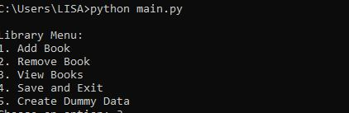

**How to remove a book**

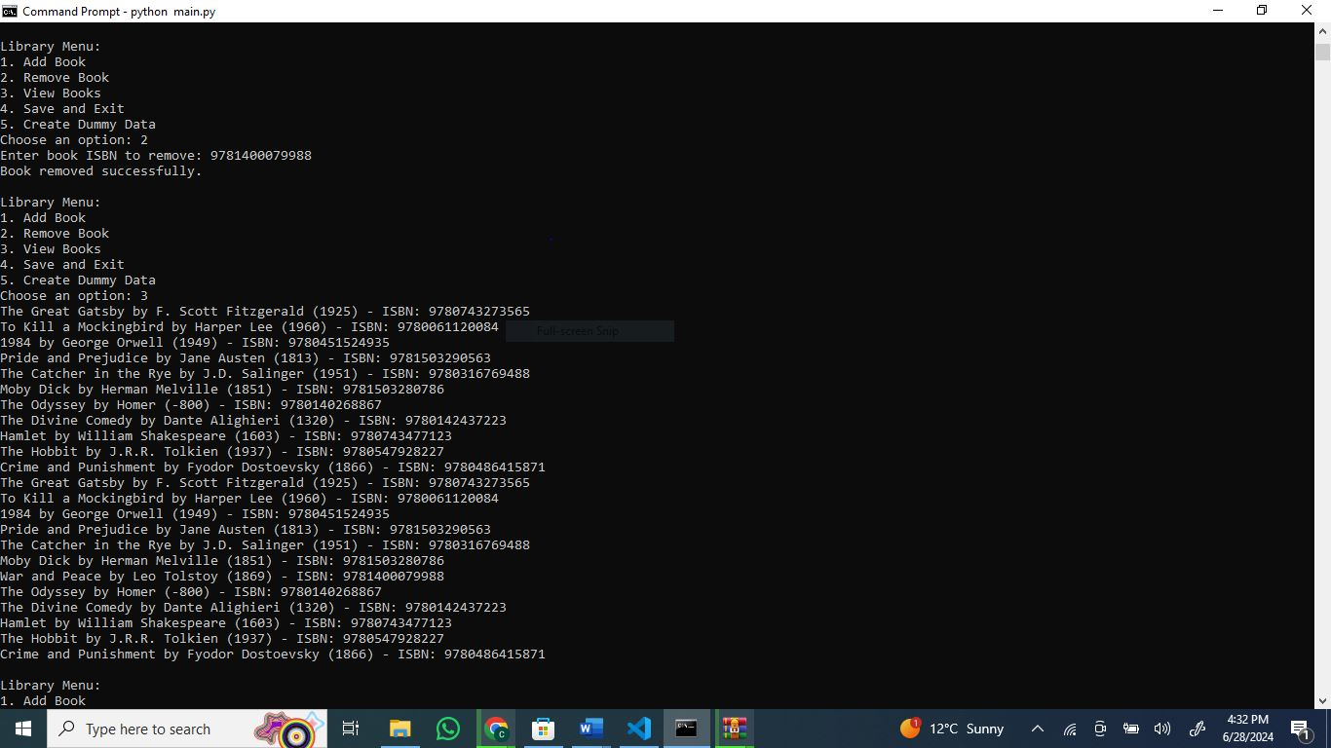

**How to add a book**

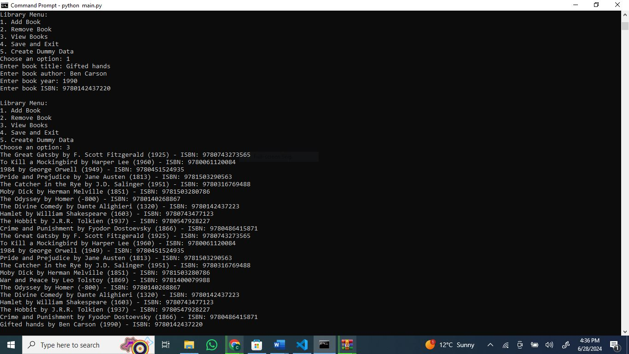

**How to create dummy data**

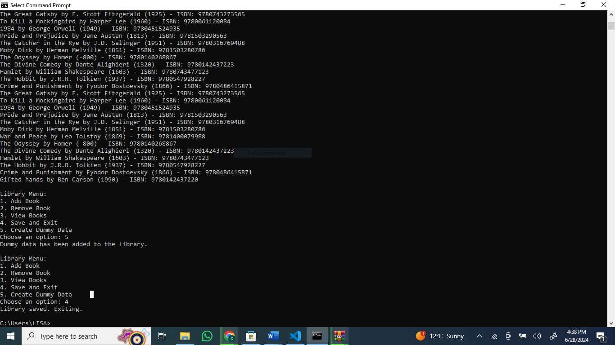

**How to view the Library books**

